|  |
| --- |
|  |
| Source: https://www.flickr.com/photos/86078640@N00/2501012436 |
| Laboratory Testing Methods for Improving Vehicle Performance |
| |  |  |  | | --- | --- | --- | | Jakob Werle | Fall 2023 | Technical Communication | |

# Abstract

This project compares full vehicle laboratory test methods for improving the suspension setup process in road racing. Three candidate solutions were analyzed: 4-Post Shaker Rigs, 7-Post Shaker Rigs, and Kinematics and Compliance Testing Rigs, (or K&C Testing). Each solution was assessed on its setup requirements, acceptable vehicle range, and effectiveness of test results. For a race car to be competitive, it must maximize mechanical and aerodynamic grip, which is a function of tire mechanics and ride height. While K&C test results yield critical information about whether the chassis is effectively utilizing the tire, it fails to address transient response to live driving events. Both 4-post and 7-post shaker rig tests suggest immediately setup changes and test plans which are applicable to real racing events. Because numerous racing series rely on aerodynamic elements, the 7-post rig is the best solution for its ability to replicate and analyze aerodynamic, braking, and cornering behaviors.

# Executive Summary

This paper explores methods of testing race car suspension performance in order to more effectively develop suspension setup adjustments. Advancements in technology make it more accessible for racing teams at all levels to dive into data analysis, allowing them to make higher performing vehicle adjustments. However, due to limited track time and high operating costs of real track testing for race cars, teams look towards laboratory testing to come more prepared to race events. Arriving to racing events with an already dialed-in suspension package will allocate more testing time to fine tuning vehicle performance and therefore a higher potential for victory.

The project design requirements are to achieve optimal mechanical and aerodynamic grip balance, ensure the structural integrity of components, and validate vehicle design decisions. A desirable approach would allow racing teams to evaluate vehicle behavior in conjunction with the sensitivity of suspension parameters for specific tracks and vehicles. Ideally, suspension setup adjustments and test plans are experimentally validated and implemented within a short time frame. Functionally, a testing solution must generate results that inform engineering staff on specific changes that need to be made to change suspension behavior.

The proposed solution is 7-Post Shaker Rig testing, which records suspension performance data while a car is responding to a simulated racetrack. A 7 post rig is constructed of four wheel actuators which simulate bumps in the road and three aero-loaders that provide aerodynamic, braking, and cornering forces to the vehicle’s chassis. Together with a sophisticated data acquisition system, the 7 post rig is capable of recording precise metrics such as wheel load disturbance, ride height variation, and torsion stiffness which provide insights to the performance of the race car. While not included as the sole solution, the use of Kinematics & Compliance Testing would be complimentary to 7 post rig testing because it provides insights to deep rooted suspension behaviors that are more challenging to address alone.

The addition of 7 post rig testing to a racing team’s agenda would offer significant handling performance gains for specific track and car combinations. The widespread use of 7 post shaker rigs would be accompanied by more competitive racing series which would increase market appeal. The decrease in travel and financial demands compared to traditional track testing make 7 post testing appealing to all racing levels for logistical and environmental reasons.

Table of Contents

Abstract 1

Executive Summary 2

Problem Analysis 5

Overview of problem and its significance 5

STEM fundamentals of problem 5

Lessons from prior responses to the problem 7

Project objectives and constraints 7

Candidate Solutions 8

Scope of Solutions Considered 8

Track Testing 8

Computer Simulation 9

Component Level Vehicle Testing 9

Full Vehicle Laboratory Testing 12

Explanation of candidate solutions 13

4 Post Shaker Rig 13

7 Post Shaker Rig 14

Kinematics and Compliance Testing 16

Comparative assessment of candidate solutions 19

Project Recommendations 20

Proposed solution 20

Design and implementation challenges 21

Anticipated project outcomes and impacts 21

References 23

List of Figures

Figure 1: Suspension System 6

Figure 2: Penske S-Link PHD-2 Shock Dynamometer (Penske Racing Shocks, n.d.) 10

Figure 3: Shock dyno plot - Comparing damper adjustments (Courtesy of Temple Formula Racing) 11

Figure 4: How to read a dyno plot (Penske Racing Shocks, n.d.) 11

Figure 5: 4-Post Shaker Rig Layout (Bennett, 2012) 13

Figure 6: 4-Post Shaker Rig Top View (Bennett, 2012) 14

Figure 7: 7-Post Shaker Rig Setup 15

Figure 8: Front ride height comparison between baseline and optimized (Kelly et al., 2002) 16

Figure 9: Kinematic testing simulator (Dodds & Plummer, 2001) 17

Figure 10: Influence of stabilizer bar on the change of tire’s toe angle (Jing et al., 2017) 18

Figure 11: The effect of different settings on the toe angle of the suspension (Jing et al., 2017) 18

List of Tables

Table 1: Potential Suspension Setup Options (Boggs, 2009) 8

Table 2: Comparison of Candidate Solutions 19

# Problem Analysis

## Overview of problem and its significance

The basic goal of motorsport is for one driver and vehicle to negotiate a fixed distance faster than any other competitor (Smith, 1978). Drivers must manage varying track surface conditions, weather, traffic, and the weight of fuel burn-off. Typically racing events are a combination of practice, qualifying, and racing sessions. The purpose of practice sessions is for drivers and teams to become acclimated with the new track and fine tune the vehicle’s setup package. Practice sessions are extremely valuable to racing teams as these are usually the only times that teams are willing to experiment. For series like Formula 1, teams are only granted two extra testing days throughout the entire season. Qualifying sessions see race cars outfitted in their fastest setup package, as their fastest lap time will designate in what place it will begin the race. Usually, race durations can vary from 15-minute sprints to 24-hour endurance formats. Either way, the race setup will be such that the vehicle is consistently drivable, has minimal tire wear, and is fuel efficient.

As testing time is limited, the methods used to dial in a vehicle’s setup have become increasingly important. Racecar Engineering magazine suggests that for teams to be competitive they have to take advantage of simulation tools (Segers, 2014). Improvements in technology have allowed the racing car to be analyzed before it ever touches pavement. Suspension setup is hypersensitive to specific drivers and tracks. An effective solution will allow racing teams to develop the most complete setup package for their car before arriving at the racetrack so they can be competitive.

## STEM fundamentals of problem

The concept of tuning begins with the understanding that a race car is simply four tires and a driver outfitted with devices that allow it to negotiate a track as fast as possible. Changing the configuration of any devices in the correct way can aid the driver in driving the track faster and more efficiently. The most critical of the devices begins with tires. Tires receive all road inputs and generate all tractive forces, as they are the only parts of the car in contact with the road surface(Smith, 1978). Therefore, racecar tires are sensitive to variations in loading and relative position to the ground (Smith, 1978).

There are two modes in which tires interact with the vehicle to produce traction – mechanically and aerodynamically. Mechanical grip is the result of the kinematic design of vehicle and setup of suspension components. Typical race cars have some form linkage that connects the wheels to the chassis. A spring and damper assembly allows the wheels to absorb bumps and just as importantly, control the motion of the chassis. Aerodynamic grip, which is produced by wings and bodywork, takes effect at higher speeds and is dependent on vehicle ride height and attitude.

Many of a vehicle’s dynamic parameters are designed directly into the chassis with regulations, packaging, and tire allocation in mind. This can make fundamental characteristics of a car challenging to adjust because large weldments and assemblies would need redesigned. Several parameters of racecar have been designed into a window of operation and have corresponding mechanical adjustments that can be made by a technician. The number and type of adjustments available varies with the type of car, typically with more complex systems found at higher levels of racing. Figure 1 displays a 3D rendering of the suspension linkages and wheel assemblies for the University of Padua’s Formula Student car.

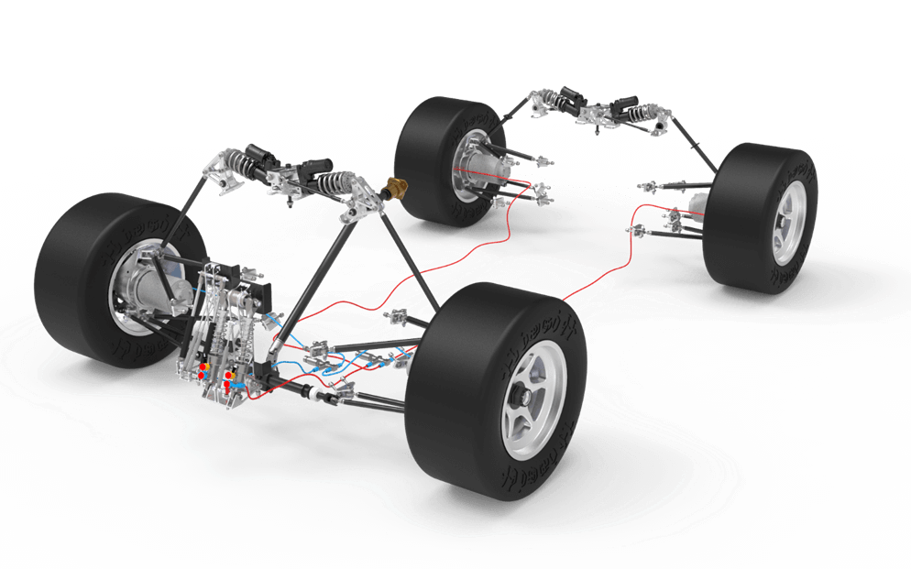

Figure : Suspension System

Gathering data for vehicle systems comes in a variety of methods but it always is focused on analyzing a particular metric. With that being said, most testing utilizes a variety of equipment. Most of the time the metric boils down to measuring a force, position, or acceleration of components. There are many ways to capture each vehicle parameter. For example, tire loads can be collected using load cells while driving or by monitoring feedback loop data from shaker rig posts.

Since one goal of improving suspension performance is minimizing wheel load divergence (Kelly et al., 2002), the data gathered needs to be organized appropriately. It is widely understood that minimizing normal load variation of each tire will result in better vehicle handling (Kelly et al., 2002). Since more downforce is created at lower ride height, having better control of the vehicle’s platform is critical (Kelly et al., 2002). Being able to run the vehicle as low as possible without upsetting the chassis and suspension will allow the most traction to be extracted from the tires, resulting in the most performance.

In a paper by wrote by Vanhees and Maes, the vibration behavior of a vehicle is broken into three main groups (G & M, 2002). Frequencies between 0-25 Hz are attributed to handling and ride, the 0-100 Hz range is for harshness and comfort, and the 50-10000 Hz range is concerned with vibrations that affect structural integrity (G & M, 2002).

## Lessons from prior responses to the problem

* What things have been successful in testing
* What problems have persisted since beginning solutions
* What ideas from a range of solutions could be helpful to continue using?
  + Ex. Simulated damper sweeps in 4 post rigs could be used in K&C
* Infrastructure challenges from building rigs
  + Expensive
  + Need engineers to work the machines
  + Lots of machines and concrete
  + Locations – racing teams are worldwide
* Where testing has been conducted and lack of data
  + Racing teams secrete equipment and data
  + Few locations

## Project objectives and constraints

The goal of this project is to analyze existing forms of dynamic vehicle testing and suggest methods that will yield the most effective improvements to vehicle performance. It is explained that successful testing results are able to provide a variety of setup changes that would benefit the vehicle (“Seven-Post Rigs,” n.d.). Since racing events take place in ever changing conditions, being able to have options for vehicle behavior is beneficial. Good data is able to help an engineer draw correlations between parameters that might not have been seen without testing. Also, it can narrow the window of what is understood to be suboptimal setup choices.

Another aspect of selecting a testing method is determining the type and quantity of data points to be analyzed. Due to the decreasing costs of electronics and growth of technology, adding data acquisition to vehicles and testing apparatuses has become very accessible (Segers, 2014). Engineers can quickly add enough sensors to swamp the data logging system. In addition, the number of setup options can become overwhelming. As seen in Table 1, for even a fairly standard vehicle package, the number of individual adjustments is significant (Boggs, 2009).

Table : Potential Suspension Setup Options (Boggs, 2009)

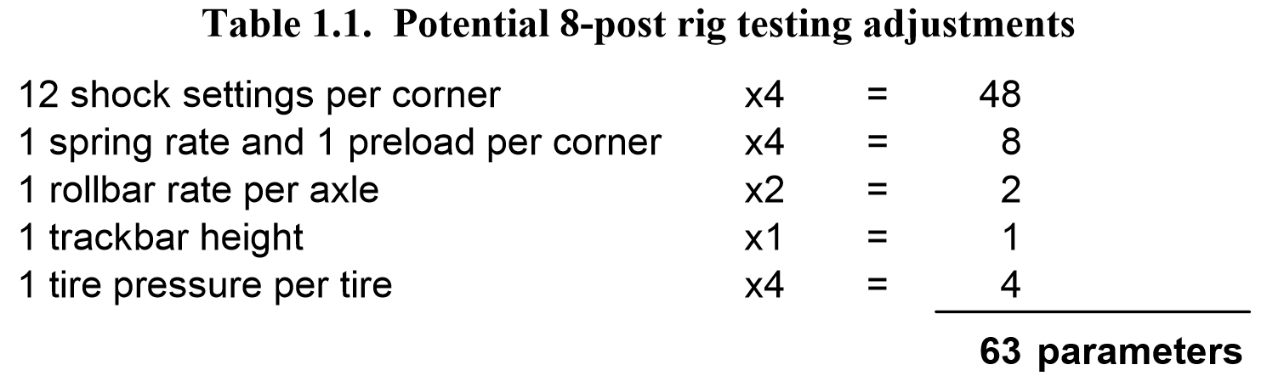

It is desirable for the analysis to be efficient, which requires the least amount of time between testing and results.

Ideally, using simulation testing tools decreases the cost for a racing team to be successful. Unfortunately, this reality is not feasible because of the inevitable costs associated with more testing.

For a given series, the competitors will be made aware of what tracks they will race at far in advance. Since a unique setup is desirable for each track, simulation testing would be conducted for each racing event.

# Candidate Solutions

## Scope of Solutions Considered

### Track Testing

The most fundamental form of tuning the race car is track side tuning. While track tuning does not take advantage of engineering tools and extra time found in a lab, it is worth understanding the most fundamental approach. Furthermore, for all methods that will be analyzed, track tuning will remain as one of the last steps in validating a setup adjustment.

A typical track tuning session consists of shaking down the car and running through a testing plan. The shake down is an essential step in which the car and driver are introduced to the new track. A testing plan is developed before the testing day and targets a particular segment of the vehicle. As progress is made with the vehicle’s performance, the testing plan can be adjusted to target more vital aspects of vehicle’s handling. Because adjustment decisions are made based on analyzing vehicle data and driver feedback after each session, the duration of the testing process can be lengthy.

Major benefits of track tuning are that the car will be in virtually the same environment as when it competes. On a similar note, the vehicle’s components will respond to track stimuli in their natural way, which is something that needs to be accounted for when putting the car on various testing rigs. The level at which testing is done comes down to the data acquisition system fitted with the vehicle and efficiency of the crew. A simple data system can cost hundreds to thousands of dollars. For lower levels of racing, the performance gain of a data system can be negligible without a track side engineer, which can significantly increase costs. Weather also needs to be factored into a testing plan, as rain or accidents can have major effects on scheduling and performance results. Performance analysis is also limited to the vehicle’s data logging system, as the number and type of sensors used depends on the system’s available inputs. Custom logging systems allow full customization of data acquisition but are typically found at higher levels of racing due to increased cost and development.

### Computer Simulation

An alternative to testing the actual vehicle is using software to simulate performance. There are many forms of simulation that allow a racing team to develop up to 99% of the car’s setup (Segers, 2014). The two main forms of simulation are Kinematic Simulation, where a car’s suspension geometry is analyzed inside software, and Lap-time Simulation, where a mathematic model of the car is used to determine the effects of various setup changes. Both forms of software simulation allow parameters of the vehicle to be tested without going to the race track (Segers, 2014).

The effectiveness of computer simulation is often associated with how detailed and complex the model of the vehicle is (Segers, 2014). To properly setup a kinematics model, the three-dimensional locations of all points which suspension linkages articulate about, called “pick-up points”, must be known. Typically, finding pick-up points involves disassembling the vehicle and measuring each component to a high precision. This process can be complex due to the need for fixturing components and creating datums to take measurements from.

### Component Level Vehicle Testing

The next logical step for racing engineers is to imperially test vehicles and their components in a laboratory setting.

A shock dynamometer, or “shock dyno” for short, is an instrument used to quantify the damping characteristics of a race car damper. Using a shock dyno can be useful in measuring performance, checking durability, or testing theoretical analysis (Gelotte, n.d.). A handful of companies have developed commercially available shock dynamometers such as Penske Racing Shock’s *S-Link PHD-2* shock dyno seen in Figure 2.

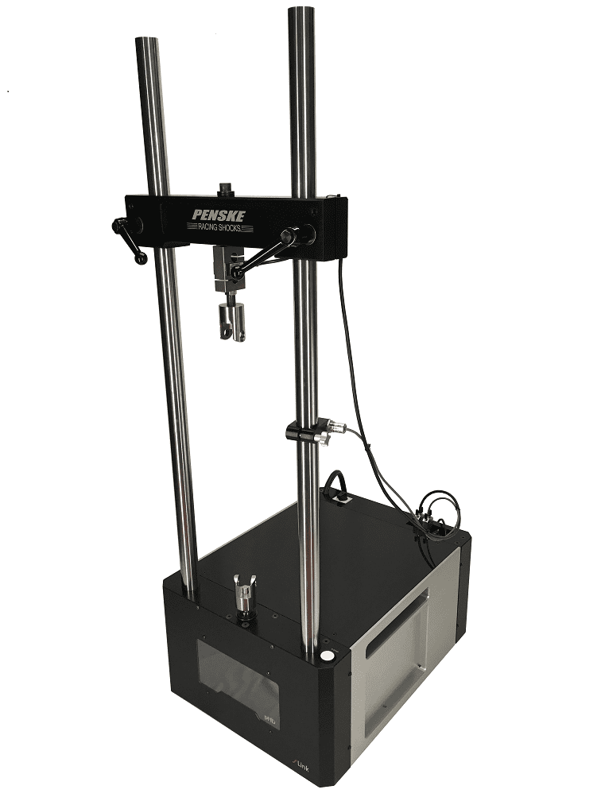

Figure : Penske S-Link PHD-2 Shock Dynamometer (Penske Racing Shocks, n.d.)

A shock dyno works by moving a racing damper through its range of motion while recording its velocity and force output. Typically, the damper is connected to a crank-slider mechanism which rotates at constant velocity, creating a sinusoidal motion. Because the dyno’s motion is created from a crank, the dyno must be paired with a damper of corresponding stroke length.

The main results yielding from dyno testing come in the form of Force vs Velocity plots as seen in Figure 3 and Figure 4. The graph is read by evaluating the force output of the compression and rebound stroke of the damper (Penske Racing Shocks, n.d.). Inward motion creates compression damping force on the positive axis of the graph, where outward motion induces rebound damping and negative force values. Figure 3 shows a simplified dataset which gives insight to the damping force at each speed. A more in-depth dataset is found in Figure 4, where the acceleration and deceleration phase of each stroke can be seen. Unexpected results or large amounts of hysteresis can be the first signs of dampers needing maintenance or adjustments (Penske Racing Shocks, n.d.).

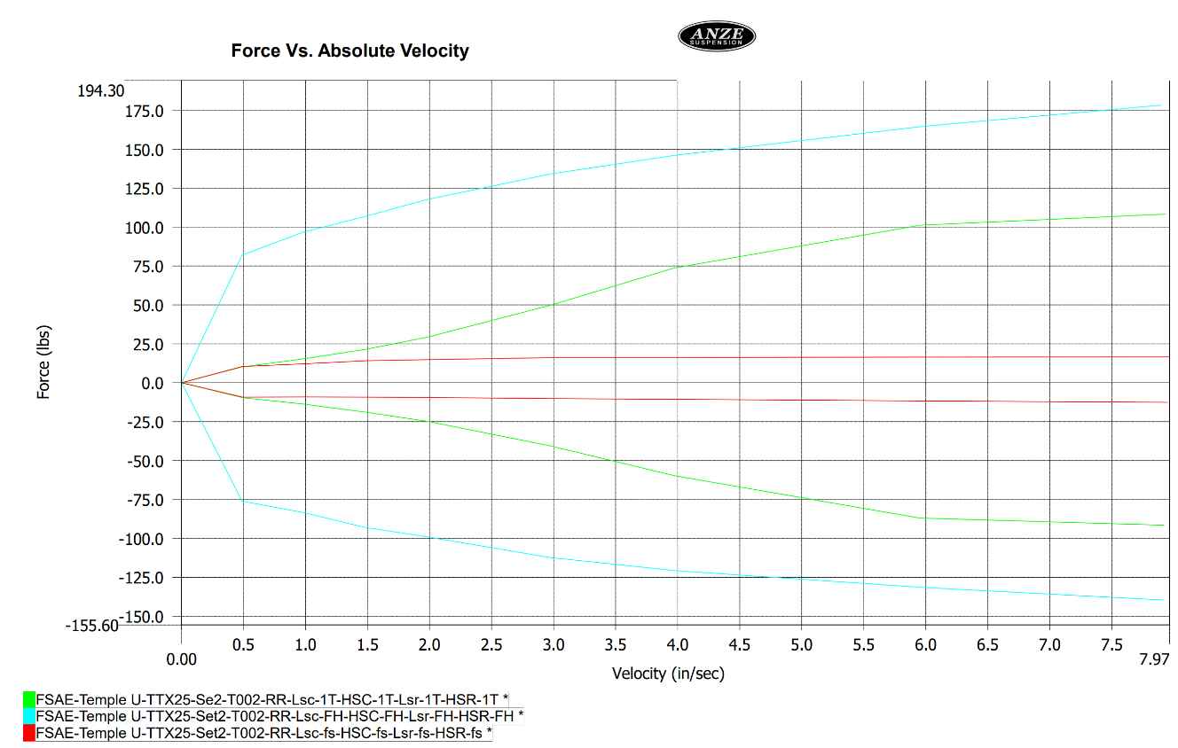

Figure : Shock dyno plot - Comparing damper adjustments (Courtesy of Temple Formula Racing)

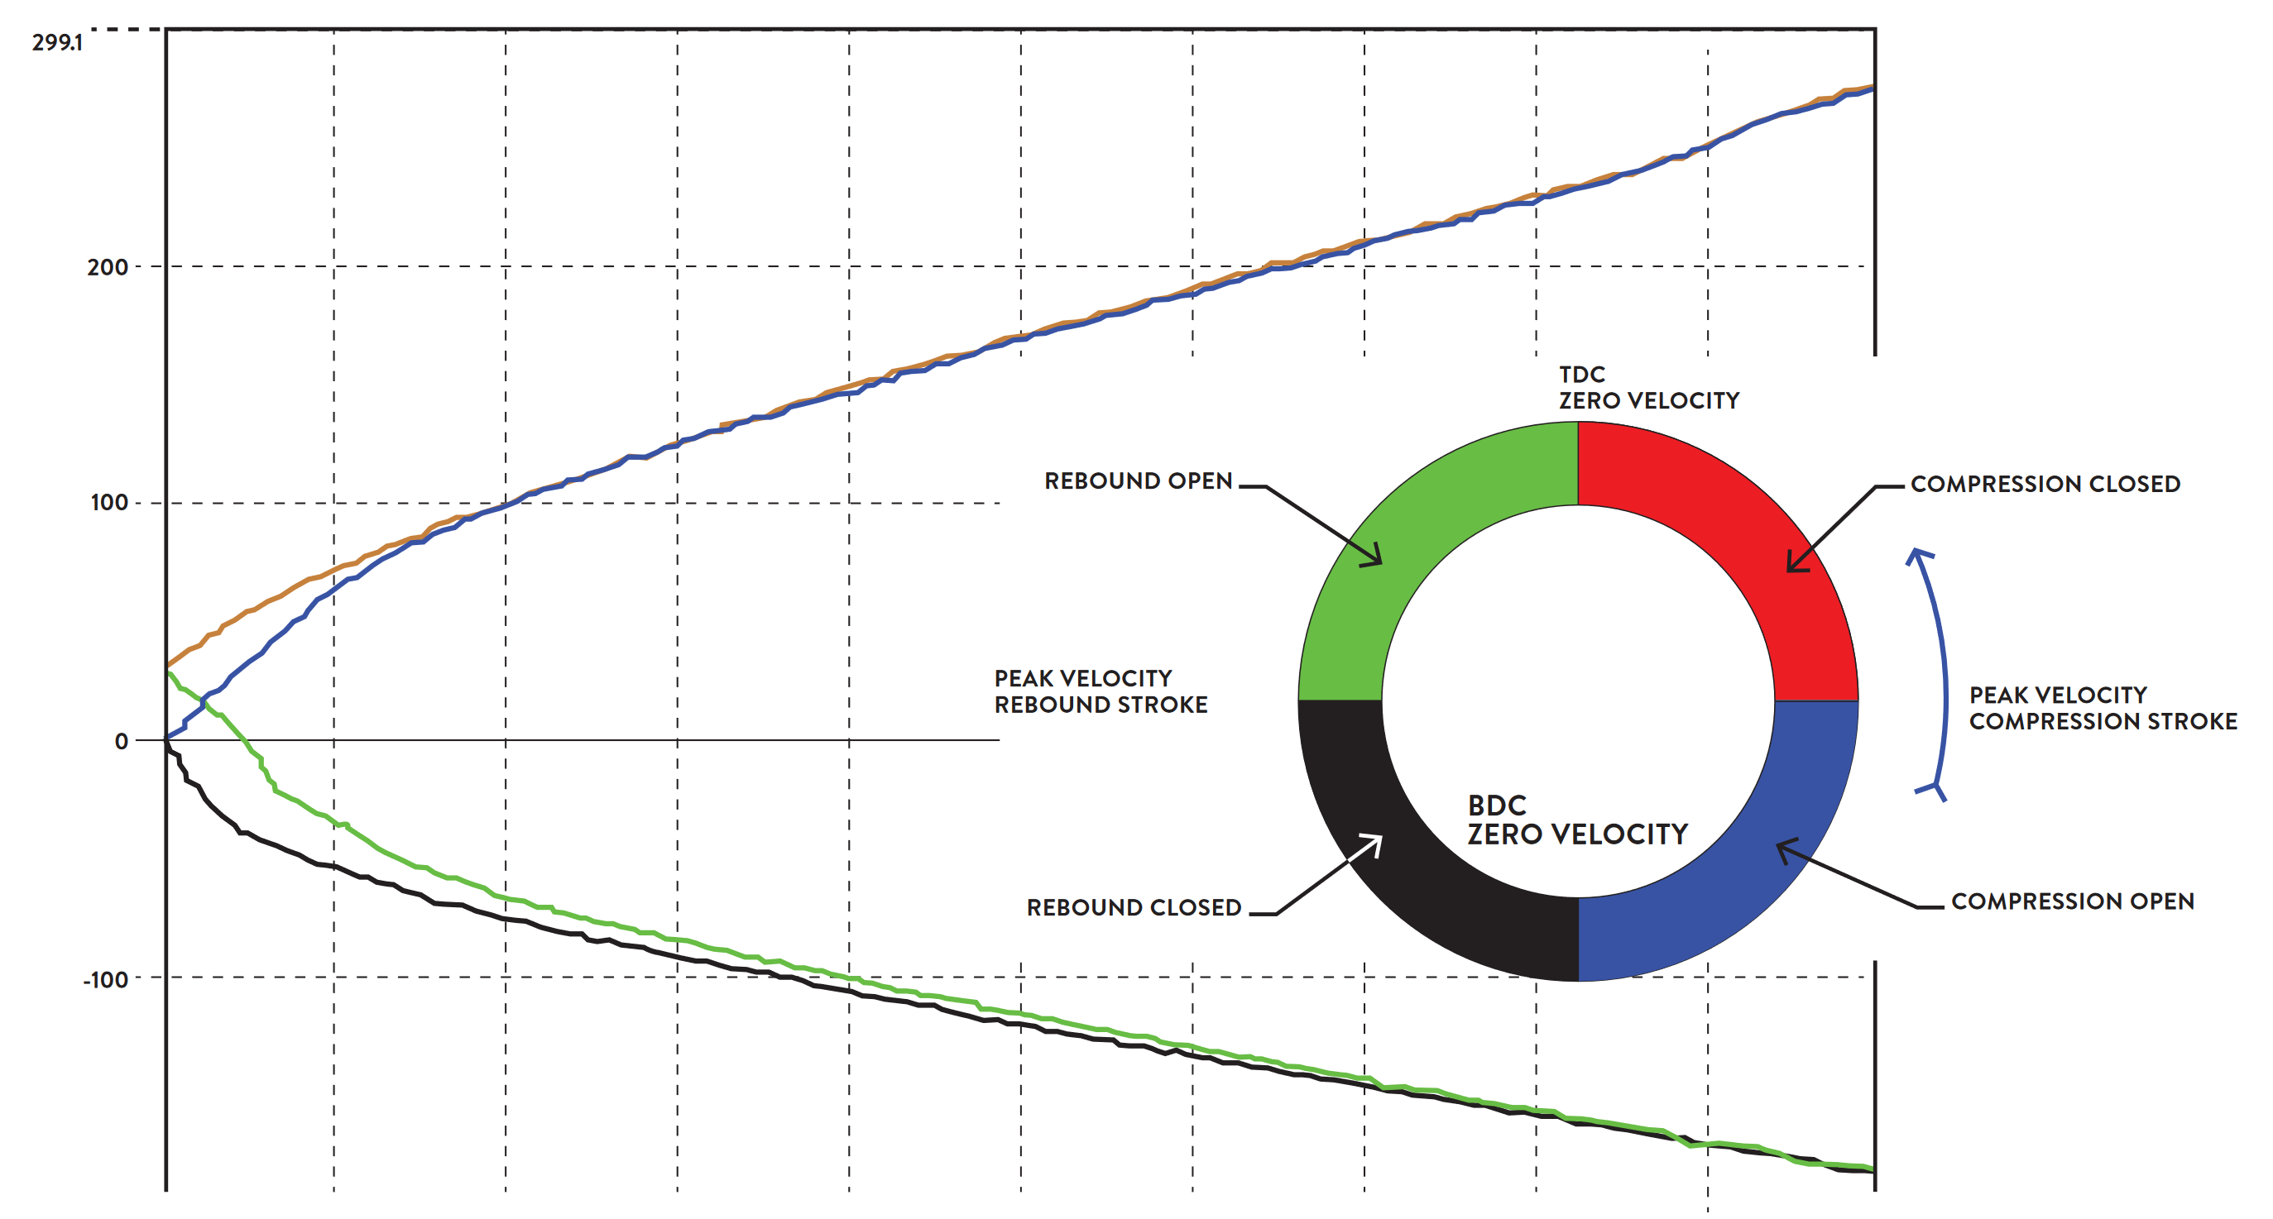

Figure : How to read a dyno plot (Penske Racing Shocks, n.d.)

Through analyzing the plot, an engineer can identify the force output at different damper velocities. Typically, the damper’s motion is broken into low and high-speed motion; where low speed is the result of transient body motion during braking or cornering, and the latter comes from the feedback of road irregularities. Shock dyno plots become useful when comparing them to driver feedback or track data in particular parts of a lap. For example, if a driver suggests a lack of performance under braking, the engineer can determine that motion’s corresponding forces then use the shock dyno to verify changes in the specified region of damping.

Despite being a powerful tool, the main drawback to a shock dyno is that it focuses only on dampers. While adjusting dampers is a critically effective tuning method, it cannot address handling concerns related to core design elements of the vehicle.

### Full Vehicle Laboratory Testing

Dynamic vehicle testing was first introduced to the laboratory environment in the 1950’s, with a focus on overall vehicle comfort and durability (Dodds & Plummer, 2001). Early testing apparatuses were designed using two-stage servo-valves and four linear actuators or posts, which were concurrently being developed by the Moog engineering company (Dodds & Plummer, 2001). To operate the testing rig, a vehicle is suspended in the air in which an individual post supported each one of the vehicle’s wheels. The posts were actuated vertically in accordance to a testing cycle which aimed to statistically replicate a vehicle’s wheel travel (Dodds & Plummer, 2001). While subjective results reported good comfort, users noted potential error from the test setup lacking lateral and for/aft forces as well as inertial forces associated with rolling tires. Furthermore, some unresolved dynamics issue with hydraulics systems used throughout the 1960’s muddied the results from “excitement simulations” (Dodds & Plummer, 2001).

The next breakthrough in dynamic vehicle testing was “Response Simulation”. GM Truck and Bus conceived that by using a vehicle as the transducer, road inputs at the tire contact patch could be determined while driving at the proving grounds. The measured wheel response could then be used to drive closed loop control of the servo-hydraulic system (Dodds & Plummer, 2001). Implementing this system improved relevance of test results and led to the creation of multiple testing software.

To increase accuracy of simulations, contemporary testing rigs have been configured to allow forces and motion in multiple directions. Triaxial systems have the ability to generate vertical, lateral, and longitudinal forces, and yaw and pitch moments at each wheel (Dodds & Plummer, 2001). These more complex setups allow analysis of vehicle characteristics such as self-aligning torque and braking, which would not be possible on previous four-post rigs. However, the setup for these tests are significantly more complex and require an extra actuator for every degree of motion (Dodds & Plummer, 2001).

An alternative method called “Body Restraint Testing” applies force and moment inputs through the chassis rather than wheels. The significance of this technique is that the inputs can be relatively small and output displacements in vertical, pitch, and roll can be large (Dodds & Plummer, 2001). Initial passive restraint setups were disadvantaged by changing the structural loading of the chassis, which skewed results. To eliminate this issue, later setups replaced fixed chassis restraints with actuators which could apply high frequency motions but respond to low frequency loads(Dodds & Plummer, 2001). These systems proved to have versatile control of the vehicle’s body and could introduce external forces such as aerodynamics in motorsports (Dodds & Plummer, 2001).

## Explanation of candidate solutions

### 4 Post Shaker Rig

The simplest form of full vehicle shaker discussed in this paper is the “4 Post Rig”. In this configuration, the racecar rests on four flat plates that are attached to vertical linear actuators. Figure 5 provides a simplified layout of a 4-post shaker rig. To perform tests, the four actuators are provided signals which move the wheel plates up and down. The resulting motion and forces coming from the vehicle are measured using a variety of sensors. A common setup involves mounting load cells and linear potentiometers on the actuators and mounting accelerometers at specific locations on the car.

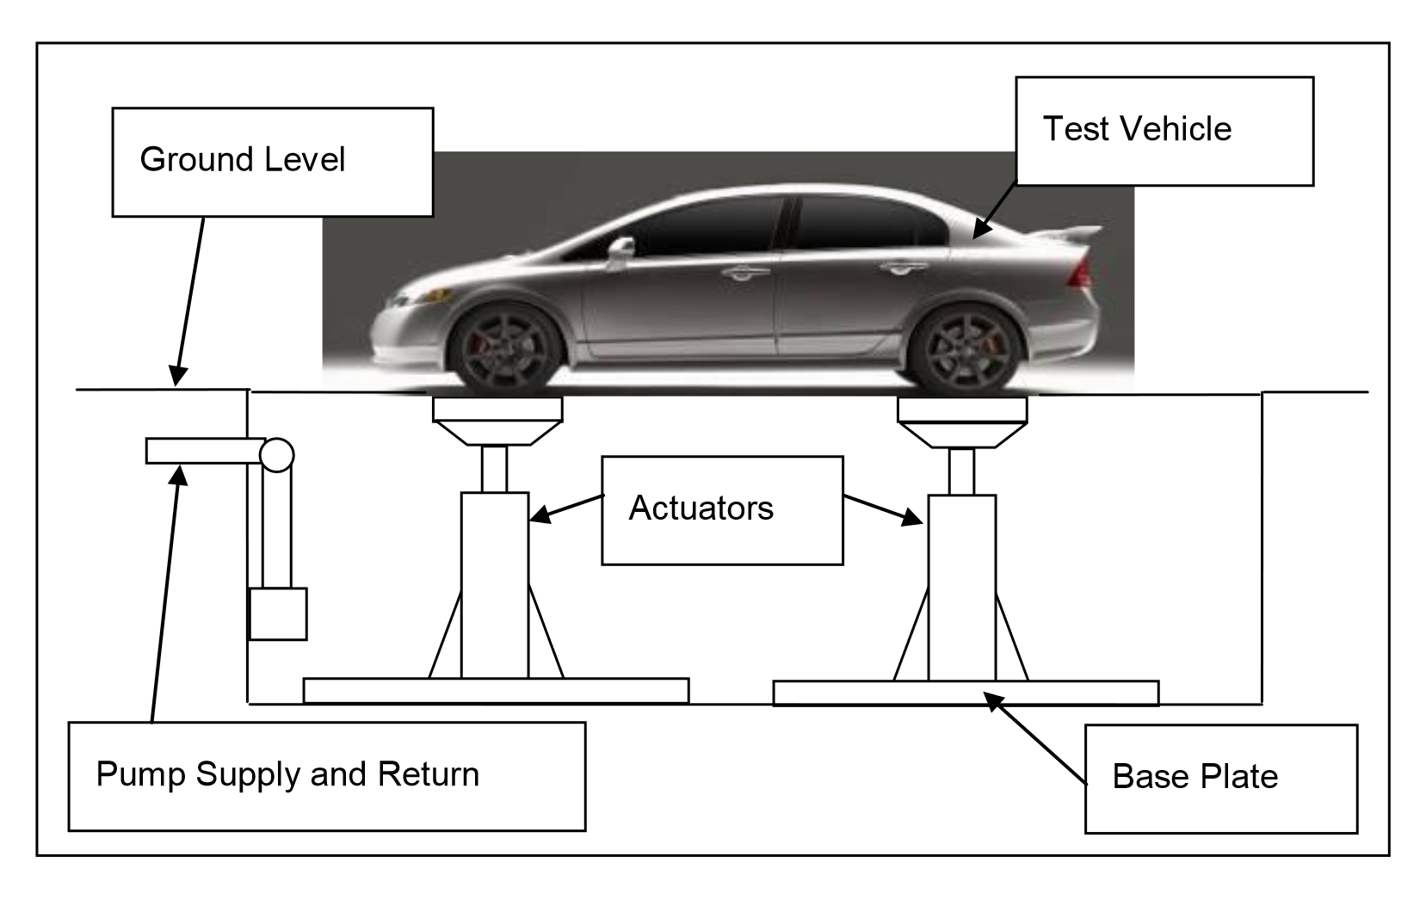

Figure : 4-Post Shaker Rig Layout (Bennett, 2012)

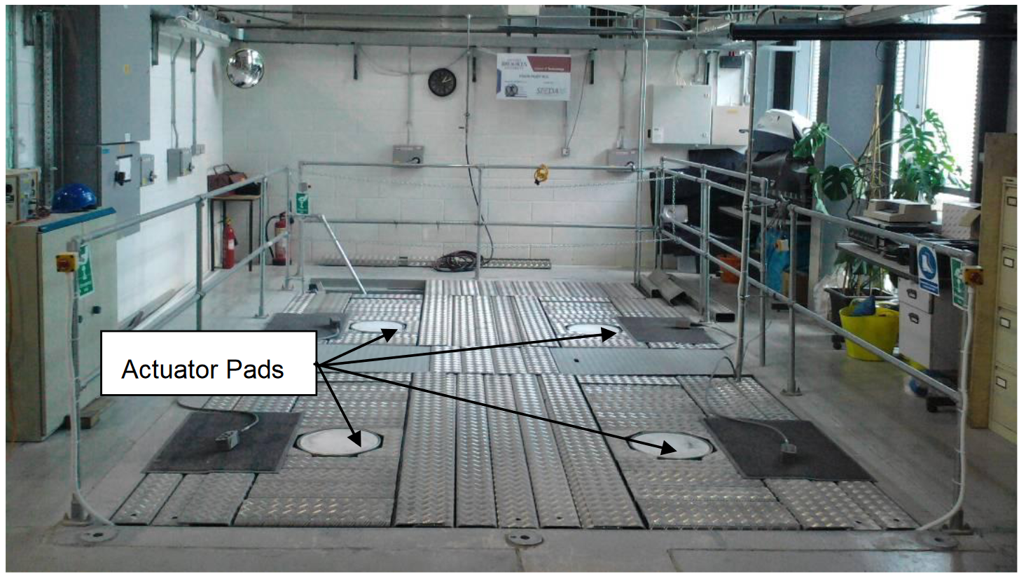

Figure : 4-Post Shaker Rig Top View (Bennett, 2012)

4-post shaker rigs are typically used to test a race car’s suspension in heave, pitch, roll, and torsion (Kelly et al., 2002).

A 4-post test was able to successfully gather data on chassis torsional stiffness, etc.…

The main drawback to a 4-post rig is that aerodynamic effects found at higher speeds are near impossible to simulate.

### 7 Post Shaker Rig

A more capable and complex configuration of a full vehicle shaker rig is called the “7 Post Rig”. The extra three posts, often referred to as “aeroloaders” can be used to generate aerodynamic forces seen above roughly 100mph (“Seven-Post Rigs,” n.d.). The three aeroloaders are fastened to the chassis using custom brackets which must be made for each unique vehicle. Figure 7 shows an example of a 7-post rig with a formula car, where the aeroloaders are fastened to the front bulkhead and rear wing mount.

Unfortunately, aeroloaders tend to dampen the vehicle’s natural response to road inputs by the wheel plates. To mitigate this, a compliant linkage can be arranged between the aeroloaders and chassis to allow loading with a sufficient amount of compliance to let the vehicle move unimpeded (“Seven-Post Rigs,” n.d.). This solution has its own issue, being that the added compliance does not allow the large downforce loads to be generated in the simulation. By using “velocity feed-forward” algorithms to predict the motion of the chassis in addition to a compliant link, a workable result emerges for downforce to be simulated on a seven post shaker rig (“Seven-Post Rigs,” n.d.).

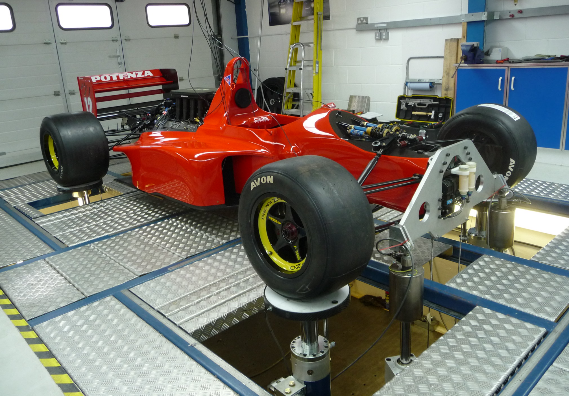

Figure : 7-Post Shaker Rig Setup

The general premise of 7-post performance analysis is like that of 4-post testing. Engineers will target setup changes that minimize variations in tire loading to maintain the highest level of traction. With the addition of aerodynamic factors, more focus is placed on ride height control (Kelly et al., 2002). Since lower ride heights result in more downforce, optimized setups will be able to maintain consistent tire loadings while keeping the vehicle platform in an aerodynamically efficient position (Kelly et al., 2002). In Figure 8, a ride height vs time plot captured from 7-post testing shows the results of optimizing a set of front dampers. The resulting setup was able to run 1mm lower and had less variation; therefore producing more downforce and control (Kelly et al., 2002).

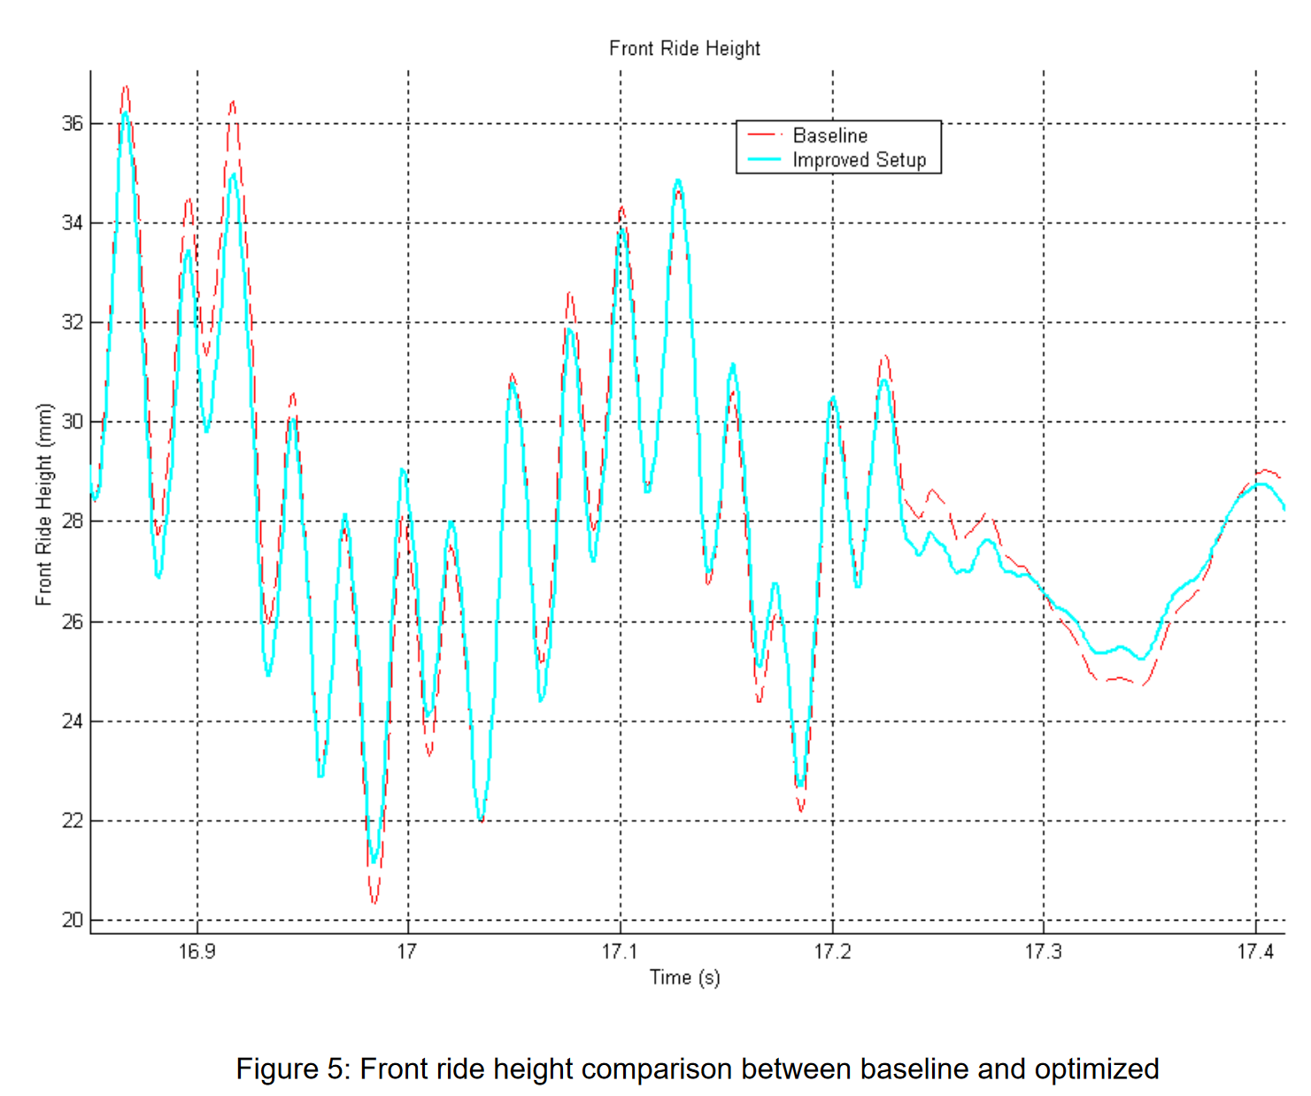

Figure : Front ride height comparison between baseline and optimized (Kelly et al., 2002)

### Kinematics and Compliance Testing

Kinematic and compliance testing, or K&C testing for short, is a laboratory method of analyzing the how suspension components of a race car move in relation to one another. This test can observe the kinematics that the real vehicle generates. This is important because inconsistencies during the manufacturing process and damage from racing can mean the actual vehicles kinematic properties could differ from theoretical ones, resulting in inferior performance. Also, this testing rig can empirically determine the kinematic properties of a vehicle without the need to geometrically define each component. The K&C testing apparatus can differ depending on the level of analysis, but typically involves suspending the vehicle with a number of actuators directly to each wheel assembly and some key locations on the chassis. Figure 8 shows one example of a K&C test rig in which there are vertical, longitudinal, and lateral motion input mechanisms for each wheel. Other configurations include one or multiple chassis mounted actuators to provide other testing conditions.

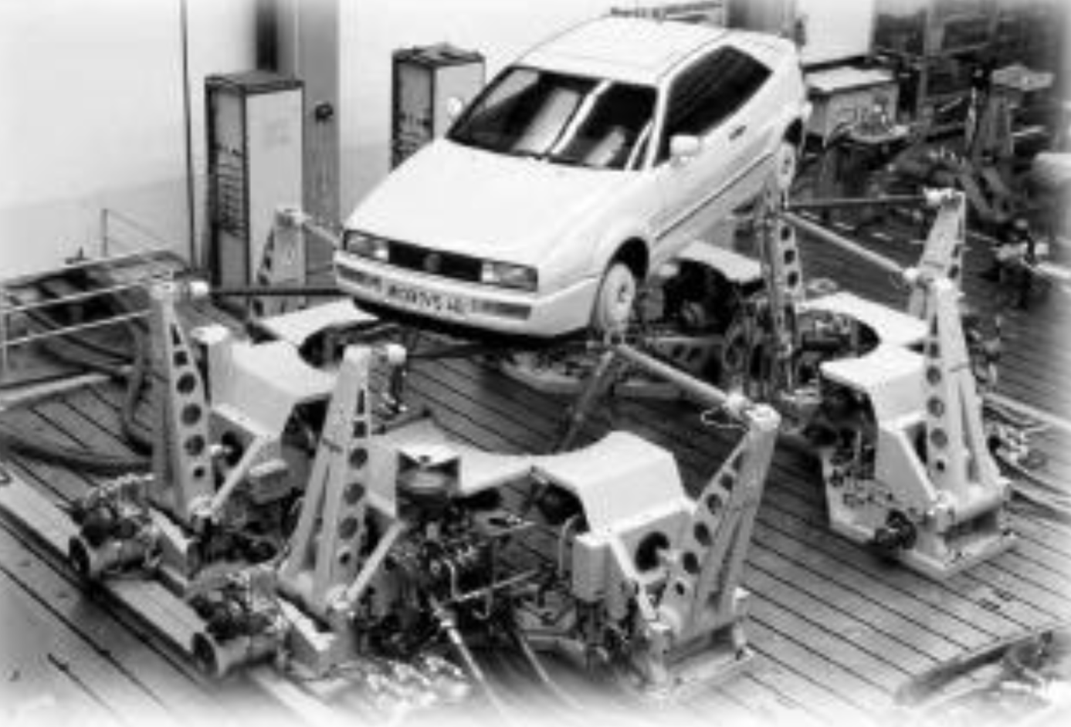

Figure : Kinematic testing simulator (Dodds & Plummer, 2001)

K&C testing can be broken into characterizing kinematics and defining compliance within the suspension system. K&C test rigs are able to provide suspension behavior data that helps engineers correlate track and subjective performance to kinematic and compliance characteristics (Best et al., 1997). It is possible to determine the sensitivity of vehicle characteristics to various suspension parameters. This means that a race car's "ideal" performance setup can be achieved while also determining a tolerance bandwidth (Best et al., 1997).

Work has been done to use K&C test rigs to validate theoretical kinematics results from ADAMS car (Zhang et al., 2023).

Morse Measurements explains that damper behavior needs to be calculated and added to simulations during tests.

Examples of K&C test results are shown in Figure 10 and Figure 11 where the front left wheel toe angle is analyzed. The first test demonstrates the use of K&C for kinematics characterization – where the tire position is related to transient body motion. The second test demonstrates characterizing the tire position in response to various component settings. Both tests are critical in determining whether the tire is operating in its ideal window.

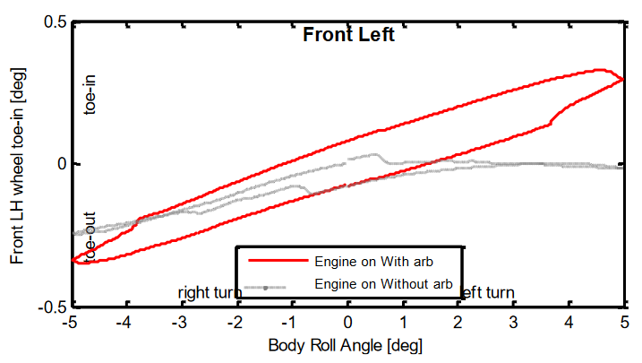

Figure 10: Influence of stabilizer bar on the change of tire’s toe angle (Jing et al., 2017)

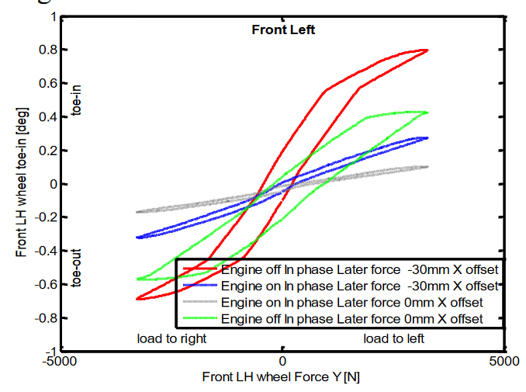

Figure : The effect of different settings on the toe angle of the suspension (Jing et al., 2017)

## Comparative assessment of candidate solutions

Table : Comparison of Candidate Solutions

|  |  |  |  |
| --- | --- | --- | --- |
|  | **4 Post Rig** | **7 Post Rig** | **K&C Testing** |
| Required Testing Rig Preparation | Adjust wheel plate locations | Adjust wheel plate locations, requires compliant link and feedforward algorithm, custom brackets for different vehicles | Adjust wheel assembly mount locations |
| Rig Data Channels | * 4x wheel actuator displacement * 4x wheel contact load * 4x wheel actuator acceleration | * 4x wheel actuator displacement * 4x wheel contact load * 4x wheel actuator acceleration * 3x chassis velocity transducer * 3x aeroloader displacement * 3x aeroloader load * Front ride height * Rear ride height * Air speed * Lateral acceleration * Longitudinal acceleration | * Suspension stiffness * Suspension friction * Ride stiffness * Roll stiffness * Tire radial stiffness * Toe angle * Camber angle * Geometric roll center * Longitudinal wheel center displacement * Longitudinal tire contact displacement * Steering transmission ratio * Steering friction * Kingpin caster angle * Kingpin inclination angle * Wheel hub flexibility * Toe angle kindliness * Camber angle kindliness * Tire contact stiffness * Anti-dive/squat |
| Required Vehicle Data Channels | * 4x hub accelerometers * 4x chassis accelerometers * 4x damper displacements * 2x damper temperature * Vertical body acceleration * Lateral body acceleration * Longitudinal body acceleration | * 4x hub accelerometers * 4x chassis accelerometers * 4x damper displacements * 2x damper temperature * Vertical body acceleration * Lateral body acceleration * Longitudinal body acceleration |  |
| Simulation Modes | * Quasistatic tests * Track simulation for low downforce cars | * Quasistatic tests * Track simulation extended to high downforce cars | * Quasistatic tests * Generalized testing of expected forces and motions * NO damping |
| Testing Duration |  |  | Loading, testing, unloading vehicles in **less than 2 days** |
| Major test results | * Wheel load distribution * Ride height variation analysis * Pitch sensitivity analysis * Torsional stiffness | * Wheel load distribution * Ride height variation analysis * Pitch sensitivity analysis * Torsional stiffness | * Vertical loading conditions, * Lateral loading conditions * Longitudinal loading conditions * Roll conditions * Steering conditions * Correction force conditions |

# Project Recommendations

## Proposed solution

The ideal solution for racing teams to improve setup package development must be time efficient and yield a variety of specific test results. The comparative assessment shown in Table 2 leads to the conclusion that the 7-Post Shaker Rig is the best solution for setup development because of its fast turnaround times and wide range of use cases.

Based on the knowledge that more normal loading on a tire generates more grip, having a more consistent load for each tire on the car will increase performance. There are two modes to this – one is that when encountering bumps in track surface, the wheel can monetarily lose contact with the ground and then gradually come back into contact, based on spring rates and damping. This rate of road contact will align with tire loading and henceforth, grip levels. The other mode deals with the distribution of load to each wheel from transient motion in corners, braking, and acceleration. For both scenarios, tuning spring rates and dampers provides the most immediate results to control the chassis motion and therefore load consistency and distribution. The *Wheel Load Distribution* and *Ride Height Analysis* tests from shaker rigs can provide general and track specific test results that correlate specific spring rate and damper settings to performance targets. Having the benefit of running track specific simulations allows teams to perform a comprehensive setup analysis and prepare testing plans with the equipment they have available before arriving at the track. K&C testing is also able to analyze tire loading conditions, but only for specific predefined vehicle behaviors. The absence of transient analysis in this testing leaves a level of uncertainty for setup procedures for specific tracks.

There are many tests that both shaker rigs and K&C testing can do that translate to whether the racing tire is being used to its fullest potential. Recalling tire dynamics, the main tire parameters related to the production of grip are normal loading, slip angle, and wheel camber. The latter two parameters are directly defined by kinematics and steering geometry and can be precisely analyzed through data rig channels in K&C testing. Combining these analytics with tire data from the tire manufacturer or external tire testing facility can provide vital information on the performance of the race car. Specific kinematic behaviors can be targeted, and because said behaviors are parameterized by deep rooted chassis design choices, can be more challenging to create immediate solutions for. However, tracking problematic or beneficial suspension behaviors over time can build enough evidence to make more signific, time consuming design changes to suspension components. If suspension behavior is far from optimal, K&C testing offers a substantial benefit that tuning dampers would only band aid.

Kinematics and compliance testing can provide critical vehicle information but is not able to replicate one to one scenarios in the way the shaker rig can. 4-post and 7-post shaker rigs can generate comparable results. It is a given that being able to generate aerodynamic forces gives an advantage to the 7-post rig. Even for low downforce racing series the ability to replicate subtle aerodynamic effects provides an extra layer of accuracy in the analysis. 7 post testing with additional K&C evaluation are complimentary to find significant, long-term gains in performance. 7 post testing if only optimizing current package.

## Design and implementation challenges

The design or use of shaker rigs is contingent on the size and level of the racing team involved. For recreational level racers, access to simulation shaker rig technology is limited to commercial facilities. However, Clemson University’s FSAE racing team showed that having the right connections can be beneficial when they tested their race car at the Ohlin’s testing facility in Hendersonville, NC (Miller, 2002). Lack of access should not directly affect results from test sessions but may have an adverse impact on a team’s ability to consistently test their vehicle. At the professional level, it is more common to see teams build their own test facilities where they can perform tests year-round. Constructing a shaker rig facility requires custom rooms with concrete floors which are several feet deep to isolate the violent vibrations that are outputted from the equipment. In addition, there is a significant amount of computational equipment needed to operate the actuators. For most teams, whether they use a commercial facility or construct their own test rig will come down to the costs of transportation, facility commissioning, and time.

There are thousands of unique setup configurations which make testing every option out of the picture. In Boggs’s PhD dissertation, he discusses implementing a system to predict shaker rig test results by building a vehicle model using experimental data (Boggs, 2009). By simulating test rig behavior, the productivity of shaker rig testing was able to be increased (Boggs, 2009). Relevant applications of simulation included suggesting or eliminating setups to test, identifying vehicle performance tradeoffs, and identifying the sensitivity of various setup parameters of performance (Boggs, 2009).

Simulating aerodynamic loading faces challenges regarding artificial damping. Racecar Engineering discussed how adding actuators and restraints to the vehicles chassis creates unnatural damping throughout the testing apparatus (“Seven-Post Rigs,” n.d.). Since the entire actuator system relies on a feedback loop from the car’s sensors, the inaccuracies in body motion lead to inaccuracies in test results (“Seven-Post Rigs,” n.d.). Further development in his aero showed that by putting partially compliant linkages between the aeroloaders and chassis and introducing motion predicting feed-forward algorithms, accurate test results were achieved (“Seven-Post Rigs,” n.d.). Other test inaccuracies include static tires behaving differently that rotating tires. This issue highlights an overarching concern which is that simulation test results still need to be validated.

## Anticipated project outcomes and impacts

Teams that choose to implement shaker rig testing should be able to make informed setup decisions for racing events. Clemson University have provided experimental procedures that resulted in tangible setup adjustments and validation for fundamental design choices (Miller, 2002). Kelly, et al also wrote a paper that uses data collected from the Auto Research Center of Indianapolis, IN to provide examples of frequency analysis and ride height control on a formula car (Kelly et al., 2002). There is clear evidence that the use of 7 post shaker rigs helps develop higher performing race car setups faster than traditional track testing.

Logistically speaking, 7-post shaker rig testing requires less travel and operating expenses than traditional track testing. There are shaker rig facilities in most major regions across the United States, Europe, and Asia, where motorsports are most prevalent. The decreased necessity for track testing also decreases the risk for motorsports accidents and injuries.

The impact of shaker rig technology extends beyond individual teams. In racing series with multiple vehicle choices, it is important for each car to be relatively competitive to create a fair and skill focused racing event. This is called field homologation. In series like the IMSA WeatherTech Sportscar Championship, GTD and GTD Pro teams could choose from at least ten various makes and models of cars, all of which follow a strict homologation (IMSA, 2024). Since each car has been uniquely designed, their performance strengths and weaknesses need to analyze to determine how to effectively balance suspension parameters. If sanctioning bodies such as IMSA were to employ 7-post shaker rig testing procedures, all cars would benefit from deep suspension performance analysis and therefore the ultimate potential of each car could be brought closer together. This is also a situation where the addition of K&C testing would be quite significant. Since premier racing series are closely tied to the vehicle manufacturers, the deeper design changes that K&C testing might suggest are not out of the question. Like most racing series, IMSA car designs build off the same platform until major overhauls. Keeping track of both 7-post shaker rig and K&C test results would provide IMSA significant data to suggest homologation changes. While individual teams are attempting to increase the performance gap between themselves and their competitors, series investors and fans are drawn to a more exciting racing event.

# References

Bennett, L. J. (2012). Ride and Handling Assessment of Vehicles Using Four-post Rig Testing and Simulation. *Oxford Brookes University*.

Best, T., Neads, S. J., Whitehead, J. P., & Willows, I. R. (1997). *Design and Operation of a New Vehicle Suspension Kinematics and Compliance Facility*. 970096. https://doi.org/10.4271/970096

Boggs, C. M. (2009). *The Use of Simulation to Expedite Experimental Investigations of the Effect of High-Performance Shock Absorbers*. https://vtechworks.lib.vt.edu/handle/10919/26108

Dodds, C. J., & Plummer, A. R. (2001). *Laboratory Road Simulation for Full Vehicle Testing: A Review*. 2001-26–0047. https://doi.org/10.4271/2001-26-0047

G, V., & M, M. (2002). *Vehicle Suspension Characterisation By Using Road Simulation on a 4-Poster Test Rig*. 63–70.

Gelotte, E. (n.d.). *Develompment of software that can predict damper curves on shock absorbers*.

IMSA. (2024). *Weathertech Sportcar Championship Results*. https://www.imsa.com/weathertech/results/

Jing, L., Wu, L., Li, X., & Zhang, Y. (2017). Study on kinematic and compliance test of suspension. *IOP Conference Series: Materials Science and Engineering*, *231*, 012186. https://doi.org/10.1088/1757-899X/231/1/012186

Kelly, J., Kowalczyk, H., & Oral, H. A. (2002). *Track Simulation and Vehicle Characterization with 7 Post Testing*. 2002-01–3307. https://doi.org/10.4271/2002-01-3307

Miller, A. (2002). *Testing a Formula SAE Racecar on a Seven-Poster Vehicle Dynamics Simulator*. 2002-01–3309. https://doi.org/10.4271/2002-01-3309

Penske Racing Shocks. (n.d.). *How to Read a Shock Dyno Graph*.

Segers, J. (2014). *Analysis Techniques for Racecar Data Acquisition—Second Edition*. SAE International. https://doi.org/10.4271/R-408

Seven-post Rigs. (n.d.). *Racecar Engineering*.

Smith, C. (1978). *Tune to Win*.

Zhang, H., Feng, G., Wang, H., Gu, F., & Sinha, J. K. (Eds.). (2023). *Proceedings of IncoME-VI and TEPEN 2021: Performance Engineering and Maintenance Engineering* (Vol. 117). Springer International Publishing. https://doi.org/10.1007/978-3-030-99075-6